# Introduction

The Star Wars API, or "swapi" (Swah-pee) is the world's first quantified and programmatically-accessible data source for all the data from the Star Wars canon universe!

Following data are available in this API.

* Planets
* SpaceShips
* Vehicles
* People
* Films
* Species

# How Can I Use It?

All the data is accessible through our HTTP web API.

The Star Wars API document provides the list of all resources available in this API and explains how to consume the resources using HTTP requests.

There are helper libraries to consume the Star Wars API in your preferred programming language. Please refer to the **Helper libraries** and **Getting Started** section before you start exploring the APIs.

# GETTING STARTED

Use httpie or curl to make an API request for a resource.

Note: We'll use httpie for our examples as it displays responses nicely and gives us a whole lot more useful information. If you don't want to download httpie, just use the curl command instead.

Following is the sample example to request a planet.

* Request Content Type: application/json
* Request URL : http swapi.dev/api/planets/1/
* Response Content Type: application/json

{

    "name": "Tatooine",

    "Rotation_period": "23",

    "Orbital period": "304",

    "diameter": "10465",

    "climate": "arid",

    "gravity": "1 standard",

    "terrain": "desert",

    "surface water": "1",

    "population": "200000",

    "residents": [

        "https://swapi.dev/api/people/1/",

        "https://swapi.dev/api/people/2/",

        "https://swapi.dev/api/people/4/",

        "https://swapi.dev/api/people/6/",

        "https://swapi.dev/api/people/7/",

        "https://swapi.dev/api/people/8/",

        "https://swapi.dev/api/people/9/",

        "https://swapi.dev/api/people/11/",

        "https://swapi.dev/api/people/43/",

        "https://swapi.dev/api/people/62/"

    ],

    "films": [

        "https://swapi.dev/api/films/1/",

        "https://swapi.dev/api/films/3/",

        "https://swapi.dev/api/films/4/",

        "https://swapi.dev/api/films/5/",

        "https://swapi.dev/api/films/6/"

    ],

    "created": "2014-12-09T13:50:49.641000Z",

    "edited": "2014-12-20T20:58:18.411000Z",

    "url": "https://swapi.dev/api/planets/1/"

}

Note: If your response looks slightly different don't panic. This is probably because more data has been added to swapi since we made this documentation.

# Authentication

Swapi is a completely open API and hence no authentication is required to query and get the data.

# Rate Limiting

The Swapi has rate limiting for handling large amount of traffic and to prevent malicious abuse of data. The rate limiting is done via IP address and it is limited to 10000 API requests per day.

# JSON SCHEMA

All the resources support JSON schema. Make a request to /***api/<resource>/schema*** to get the details of the resource.

# Searching

All resources support a ***search*** parameter that filters the set of resources returned.

Note: All searches should use case-insensitive partial matches on the set of search fields. Refer to each resource reference document to view the set of search fields for each resource.

# Encodings

Two encodings are provided namely JSON and Wookiee.

JSON is the standard data format provided by SWAPI by default.

Wookie is for tall hairy allies who speak Wookie. This encoding is identical to JSON except with wookiee translations.

Append *? format=wookiee* to the urls.

<https://swapi.dev/api/planets/1/?format=wookiee>

People Resource API

# Introduction

The People resource API refers to an individual person or character within the Star Wars universe.

# Method

GET

# BASE URL

<https://swapi.dev/api/>

# HEADERS

Authorization/Authentication: no Auth

Content Type: application/JSON

# End Point

**/people/**  - get all the people resources

**/people/:id/** -- get a specific people resource

**/people/schema/** -- view the JSON schema for this resource

# REQUEST URL

<https://swapi.dev/api/people/> - to get all the people resources

https://swapi.dev/api/people/1/ - to get a specific people resource

<https://swapi.dev/api/people/schema/> - view the JSON schema for this resource

# Response Parameters to get all people resources

| Parameter (Required/Optional) | Data Type | Values | Description |
| --- | --- | --- | --- |
| name | string |  | Name of the Person. |
| birth_year | string |  | The birth year of the person using the in-universe standard of BBY or ABY - Before the Battle of Yavin or After the Battle of Yavin. The Battle of Yavin is a battle that occurs at the end of Star Wars episode IV: A New Hope. |
| eye_color | string | Unknown - if the color is not known  n/a - if the person does not have an eye | The eye color of this person |
| gender | String | Male  Female  unknown - if gender not known  n/a - if the person does not have a gender | The gender of the person. |
| hair_color | string | Unknown - if the hair color is not known  n/a - if the person does not have hair | The hair color of the person. |
| height | string |  | The height of the person in centimeters. |
| mass | string |  | The mass of the person in kilograms |
| skin_color | string |  | The skin color of the person |
| homeworld | string |  | The URL of a planet resource, a planet that this person was born on or inhabits. |
| films | array |  | An array of film resource URLs that this person has been in. |
| species | array |  | An array of species resource URLs that this person belongs to. |
| starships | array |  | An array of starship resource URLs that this person has piloted. |
| vehicles | array |  | An array of vehicle resource URLs that this person has piloted. |
| url | string |  | The hypermedia URL of this resource. |
| created | string |  | The ISO 8601 date format of the time that this resource was created. |
| edited | string |  | the ISO 8601 date format of the time that this resource was edited. |

# Status Code

200 OK

# Sample Response Code to get all Resources

{

            "name": "Luke Skywalker",

            "height": "172",

            "mass": "77",

            "hair_color": "blond",

            "skin_color": "fair",

            "eye_color": "blue",

            "birth_year": "19BBY",

            "gender": "male",

            "homeworld": "https://swapi.dev/api/planets/1/",

            "films": [

                "https://swapi.dev/api/films/1/",

                "https://swapi.dev/api/films/2/",

                "https://swapi.dev/api/films/3/",

                "https://swapi.dev/api/films/6/"

            ],

            "species": [],

            "vehicles": [

                "https://swapi.dev/api/vehicles/14/",

                "https://swapi.dev/api/vehicles/30/"

            ],

            "starships": [

                "https://swapi.dev/api/starships/12/",

                "https://swapi.dev/api/starships/22/"

            ],

            "created": "2014-12-09T13:50:51.644000Z",

            "edited": "2014-12-20T21:17:56.891000Z",

            "url": "https://swapi.dev/api/people/1/"

        }

# Response Parameters to get People by Id

| Parameter (Required/Optional) | Data Type | Values | Description |
| --- | --- | --- | --- |
| name | string |  | Name of the Person. |
| birth_year | string |  | The birth year of the person using the in-universe standard of BBY or ABY - Before the Battle of Yavin or After the Battle of Yavin. The Battle of Yavin is a battle that occurs at the end of Star Wars episode IV: A New Hope. |
| eye_color | string | Unknown - if the color is not known  n/a - if the person does not have an eye | The eye color of this person |
| gender | String | Male  Female  unknown - if gender not known  n/a - if the person does not have a gender | The gender of the person. |
| hair_color | string | Unknown - if the hair color is not known.  n/a - if the person does not have hair | The hair color of this person. |
| height | string |  | The height of the person in centimeters. |
| mass | string |  | The mass of the person in kilograms |
| skin_color | string |  | The skin color of this person |
| homeworld | string |  | The URL of a planet resource, a planet that this person was born on or inhabits. |
| films | array |  | An array of film resource URLs that this person has been in. |
| species | array |  | An array of species resource URLs that this person belongs to. |
| starships | array |  | An array of starship resource URLs that this person has piloted. |
| vehicles | array |  | An array of vehicle resource URLs that this person has piloted. |
| url | string |  | The hypermedia URL of this resource. |
| created | string |  | The ISO 8601 date format of the time that this resource was created. |
| edited | string |  | the ISO 8601 date format of the time that this resource was edited. |

# Status Code

200 OK

# Sample Response Code to get People by Id

{

"name": "Luke Skywalker",

    "height": "172",

    "mass": "77",

    "hair_color": "blond",

    "skin_color": "fair",

    "eye_color": "blue",

    "birth_year": "19BBY",

    "gender": "male",

    "homeworld": "https://swapi.dev/api/planets/1/",

    "films": [

        "https://swapi.dev/api/films/1/",

        "https://swapi.dev/api/films/2/",

        "https://swapi.dev/api/films/3/",

        "https://swapi.dev/api/films/6/"],

    "species": [],

    "vehicles": [

        "https://swapi.dev/api/vehicles/14/",

        "https://swapi.dev/api/vehicles/30/"],

    "starships": [

        "https://swapi.dev/api/starships/12/",

        "https://swapi.dev/api/starships/22/"],

    "created": "2014-12-09T13:50:51.644000Z",

    "edited": "2014-12-20T21:17:56.891000Z",

    "url": <https://swapi.dev/api/people/1/>

}

Screenshots of API Tested in POSTMAN

# Get All People

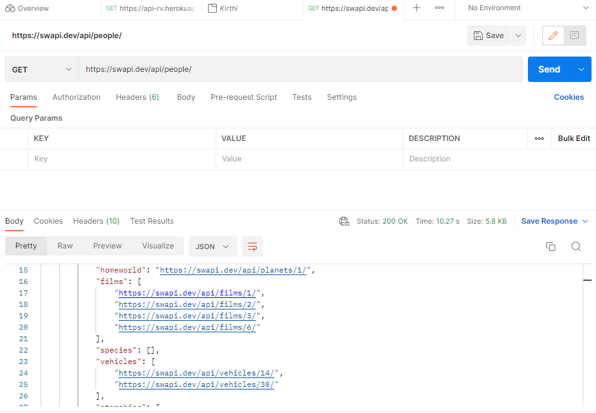

# Get People by Id

